Write, simulate, and demonstrate using Microchip Studio 7 a C code for the AVR ATMEGA328pb microcontroller that performs the following functions:

1. Mount the HC-SR04 Ultrasonic sensor on to the servo motor using the mounting plate/horn. Scan the servo motor from 0 – 120 or 0 -180 deg. Collect the ultrasonic distance (US) distance/raw value continuously during the scan during CW and CCW direction. The resolution of scan must be less than or equal to 2 deg. Display the values in UART as: “Angle, Distance (mm)\n”.

2. Display the value of each scan on the 7-SEG display on the using auto/hardware SPI mode during the CW motion. Display the lowest value of the scan in the 7-SEG display during the CCW arm return time.

**Components Used/Connected**

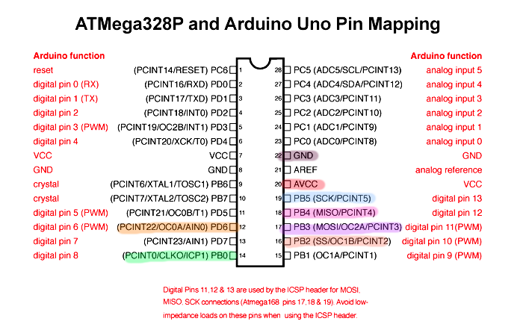

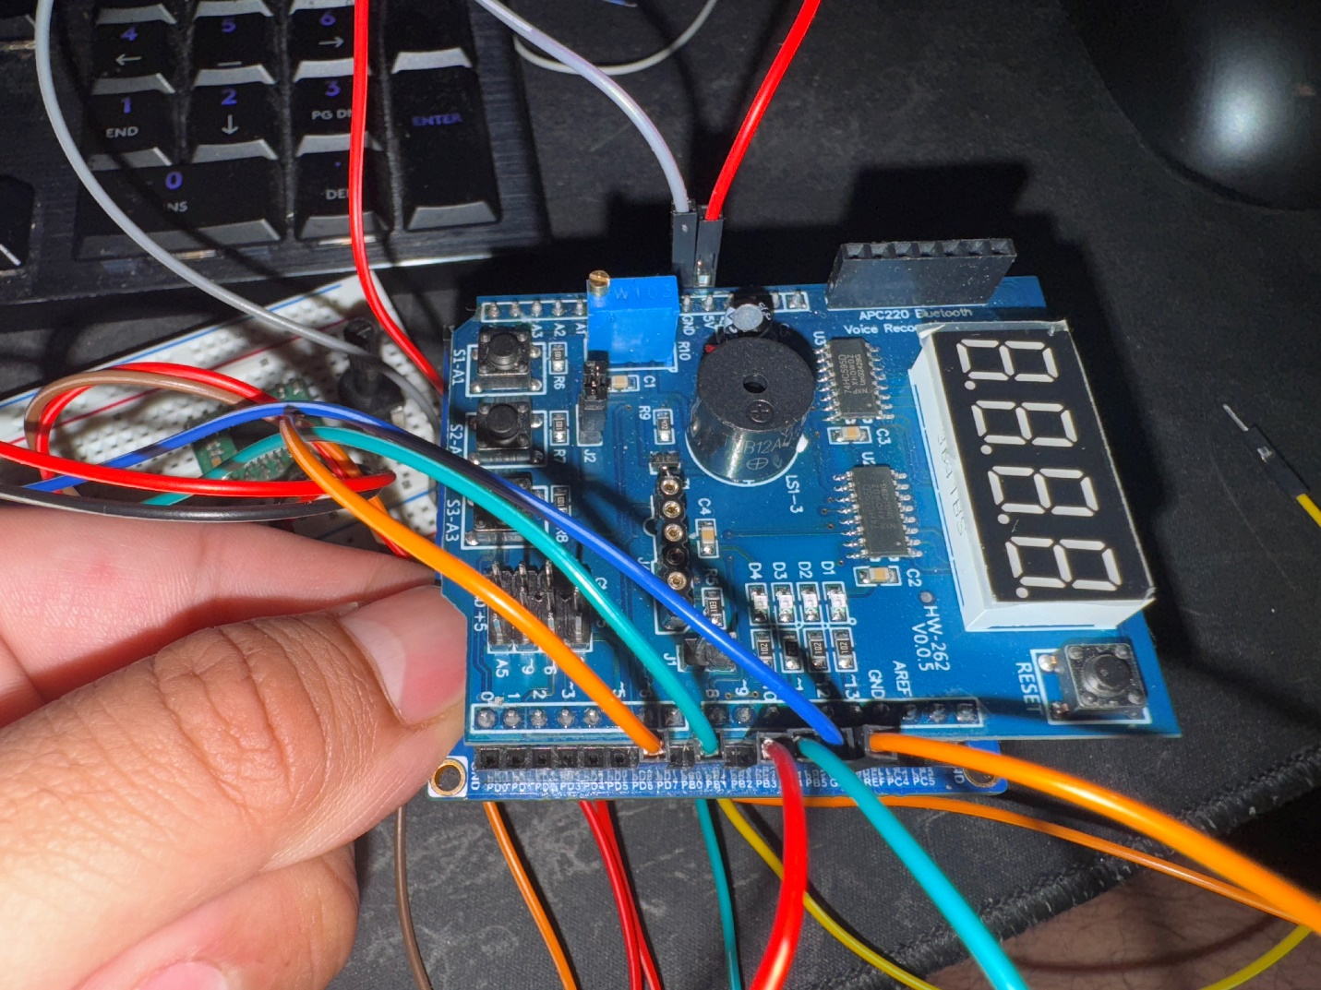

Atmega328p wiring

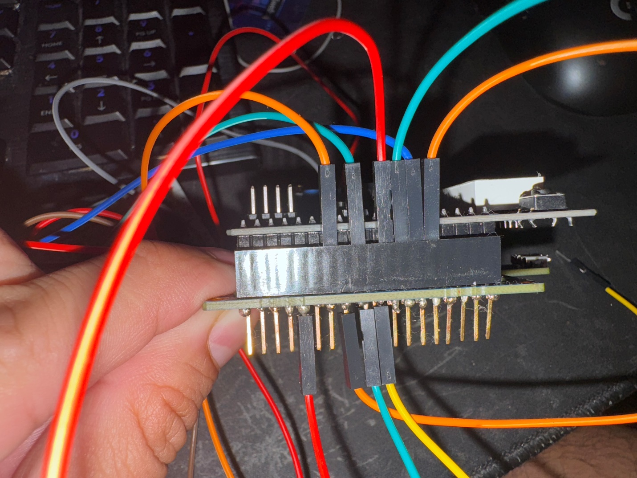

Pins for 7 Segment display (red, orange, green, yellow)

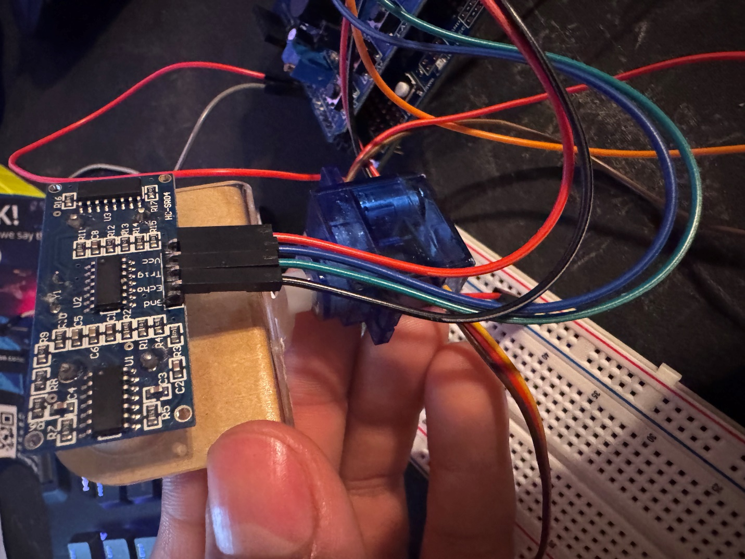

Sensor and Servo motor setup

Sensor (PB0, PB4)

Servo (PD6)

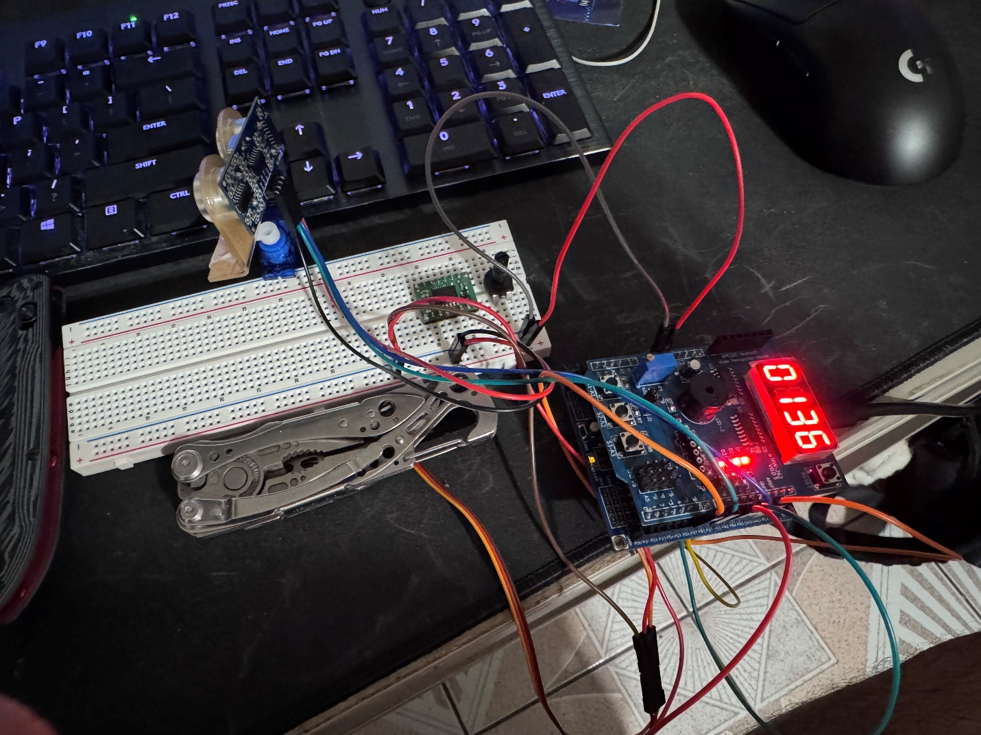

Whole setup.

Had to add weights so the servo could stand upright.

Schematic showing how the servo and ultrasonic sensor were connected. The 7 Seg was provided through the shield. DATA/MOSI PB3, LATCH/SS PB2, CLOCK/SCK PB5.

**AVR C Code**

/*

* DA6.c

*

* Created: 5/4/2025 4:48:00 PM

* Author : enriq

*/

#define F_CPU 16000000UL

#include <avr/io.h>

#include <util/delay.h>

#include <avr/interrupt.h>

#include <stdio.h>

#include <stdint.h>

// 7-segment display

#define DATA PB3

#define CLOCK PB5

#define LATCH PB2

// HC-SR04 | PB4 - TRIG | PB0 - ECHO

#define TRIG_DDR DDRB

#define TRIG_PORT PORTB

#define TRIG_PIN PB4

// Servo motor

#define SERVO_DDR DDRD

#define SERVO_PIN PD6 /* OC0A output */

static const uint8_t SEGMENT_MAP[10] = {

0xC0,0xF9,0xA4,0xB0,

0x99,0x92,0x82,0xF8,

0x80,0x90

};

static const uint8_t SELECT_MAP[4] = {

0xF1,0xF2,0xF4,0xF8

};

volatile uint8_t disp_digits[4];

static void shift_out_init(void) {

DDRB |= (1<<DATA)|(1<<CLOCK)|(1<<LATCH);

PORTB &= ~((1<<DATA)|(1<<CLOCK)|(1<<LATCH));

}

static void shift_out(uint8_t b) {

for(uint8_t i=0;i<8;i++){

if(b & (1<<(7-i))) PORTB |= (1<<DATA);

else PORTB &= ~(1<<DATA);

PORTB |= (1<<CLOCK);

PORTB &= ~(1<<CLOCK);

}

}

ISR(TIMER2_OVF_vect) {

static uint8_t idx=0;

uint8_t seg=SEGMENT_MAP[disp_digits[idx]];

uint8_t sel=SELECT_MAP[idx];

PORTB &= ~(1<<LATCH);

shift_out(seg);

shift_out(sel);

PORTB |= (1<<LATCH);

idx = (idx+1)&3;

}

static void tcnt2_init(void) {

TCCR2A=0;

TCCR2B=(1<<CS21)|(1<<CS20);

TIMSK2=(1<<TOIE2);

}

static void display_number(int v) {

disp_digits[0]=(v/1000)%10;

disp_digits[1]=(v/100)%10;

disp_digits[2]=(v/10)%10;

disp_digits[3]=v%10;

}

// UART0 at 9600

static void uart_init(void) {

UBRR0 = 103; // (16MHz/(16⋅9600))−1

UCSR0B = (1<<TXEN0);

UCSR0C = (1<<UCSZ01)|(1<<UCSZ00);

}

static void uart_tx(char c) {

while(!(UCSR0A&(1<<UDRE0)));

UDR0=c;

}

static void uart_print(uint8_t angle, int mm)

{

char buf[32];

uint8_t n = snprintf(buf,sizeof(buf),

"%u,%u\n", angle, mm); // “Angle,Distance”

for(uint8_t i=0;i<n;i++) uart_tx(buf[i]);

}

static int get_distance(void) {

// reset timer

TCNT1=0;

TIFR1=(1<<ICF1);

TRIG_PORT &= ~(1<<TRIG_PIN);

_delay_ms(500);

TRIG_PORT |= (1<<TRIG_PIN);

_delay_ms(500);

TRIG_PORT &= ~(1<<TRIG_PIN);

// rising edge

TCCR1B |= (1<<ICES1);

int t = 30000;

while(!(TIFR1&(1<<ICF1)) && --t);

if(!t) return 0xFFFF;

int start = ICR1;

// falling edge

TIFR1 = (1<<ICF1);

TCCR1B &= ~(1<<ICES1);

t=30000;

while(!(TIFR1&(1<<ICF1)) && --t);

if(!t) return 0xFFFF;

int end = ICR1;

int us = (end - start) / 2;

return ((us * 171UL) / 10000);

}

static void timer1_init(void) {

TCCR1A=0;

TCCR1B=(1<<CS11);

}

static void servo_init(void)

{

SERVO_DDR |= (1<<SERVO_PIN);

TCCR0A = (1<<COM0A1) | (1<<WGM00);

TCCR0B = (1<<CS02) | (1<<CS00);

OCR0A = 23;

}

static inline void servo_set_angle(uint8_t deg)

{

if (deg > 180) deg = 180;

OCR0A = 8 + ((int)deg * 8) / 180;

}

int main(void) {

// disable ADC & comparator

ADCSRA=0;

ACSR =(1<<ACD);

DIDR0 =0x3F;

// TRIG=output, ECHO=input

TRIG_DDR |= (1<<TRIG_PIN);

DDRB &= ~(1<<PB0);

shift_out_init();

tcnt2_init();

uart_init();

timer1_init();

servo_init();

sei();

// clear display

display_number(0);

while(1) {

static uint8_t angle = 0;

static int8_t dir = 1; // +1 CW, –1 CCW

servo_set_angle(angle);

int distance = get_distance();

uart_print(angle, distance);

if (distance != 0xFFFF) // update 7‑seg only on a good echo

display_number(distance);

angle += dir * 6;

if (angle >= 180) { angle = 180; dir = -1; }

else if (angle == 0) { dir = 1; }

_delay_ms(50);

}

}

Successful Compilation

Successfully reading values from servo and sensor.

The first value is the angle of servo motor. Second value is sensor data in cm.